Contents

Testing 1

Phase1: Image Categorization. 1

Round 1 1

Round 2 1

Round1 2

Round2 10

# Testing

## Phase1: Image Categorization.

### Round 1

Based on water at wheel level/human body level, I classified the classes into the following:

|  |  |  |  |
| --- | --- | --- | --- |
| **Description↓/Severity🡪** | **No Flood** | **Manageable** | **Severe** |
| **Flood/No Flood 🡪** | noFlood | FloodArea |  |
| **Humans** |  | pPlAnkleDeep | pPlWaistDeep |
| **Two wheeler** | 2WhlrNoFld | 2WhlrFld |  |
| **Three wheeler** | 3WhlrNoFld | 3WhlrFld |  |
| **Four wheeler light** | 4WhlrLightNoFld | 4WhlrLightFldTyre | 4WhlrLightFld |
| **Four wheeler heavy** | 4WhlrHvyNoFld | 4WhlrHvyFldTyre |  |

For each category, I added 10 or more, but in the negative category I added oceans, rivers, and this confused the model mainly in FloodArea. I have retrained it. Testing needs to be done.

### Round 2

Re Trained with some fail images and tested a bit more.

Further, there is a minor difference in color of road and water, hence the model is getting confused sometimes.

Need to add many more classes, and test it.

# Round1

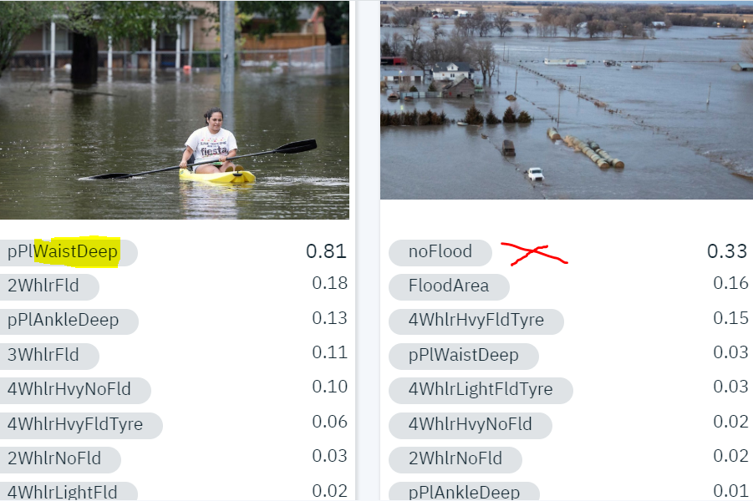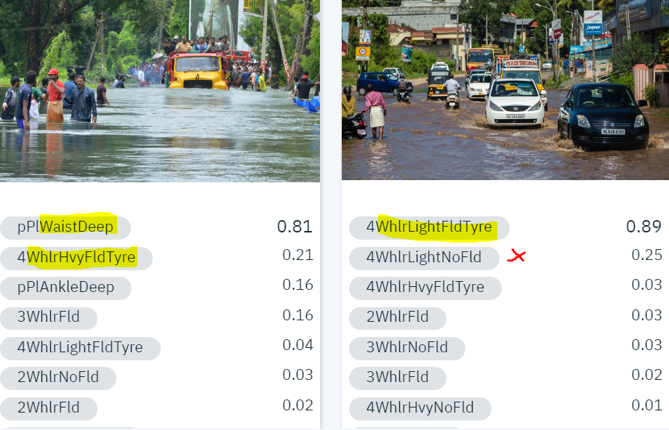

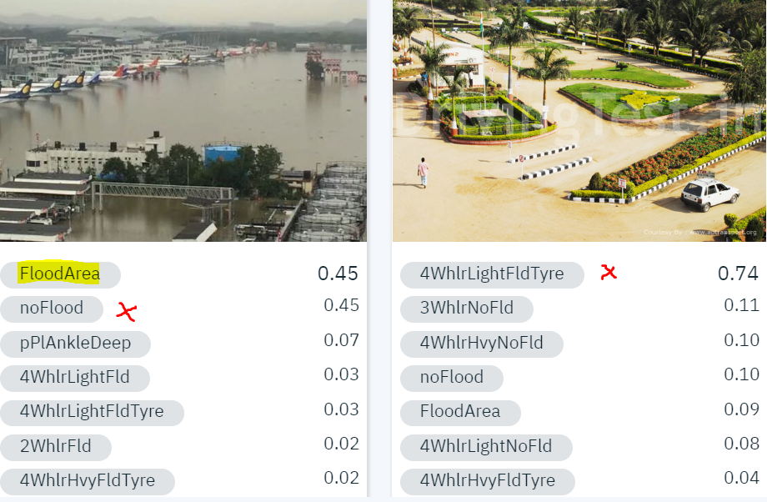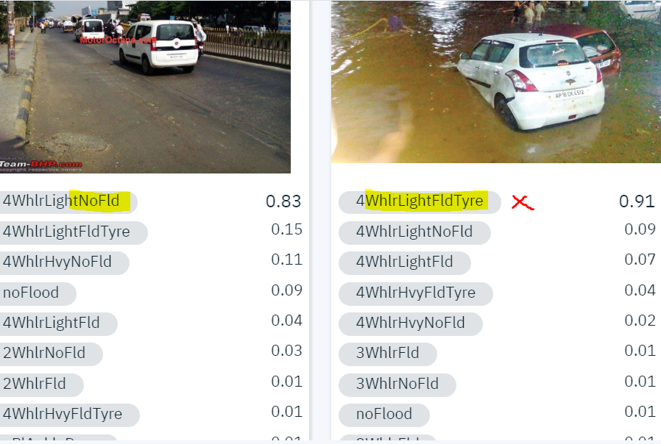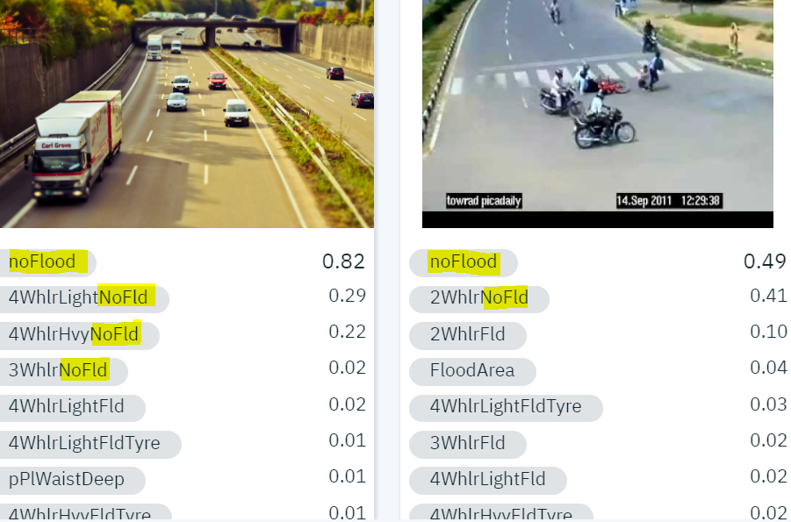

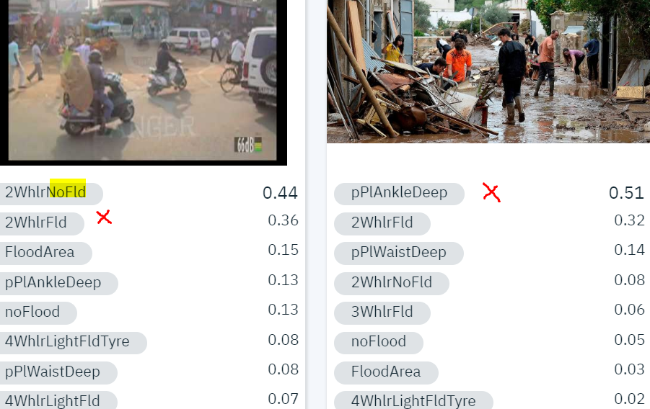

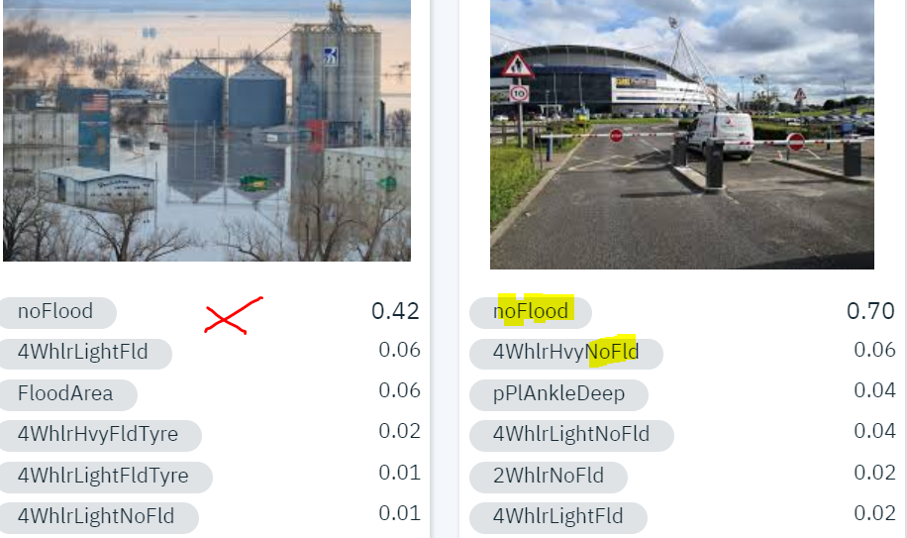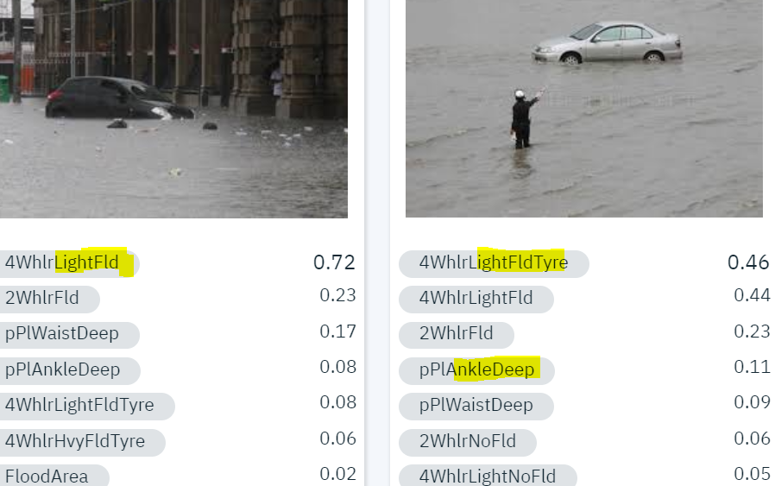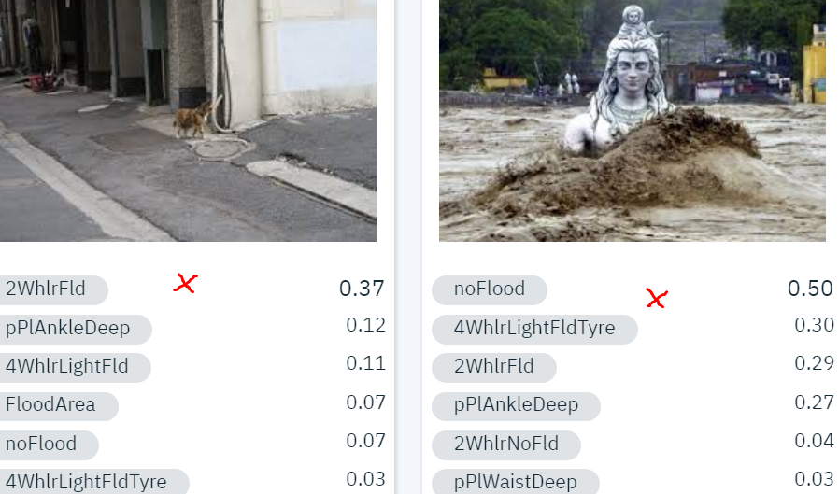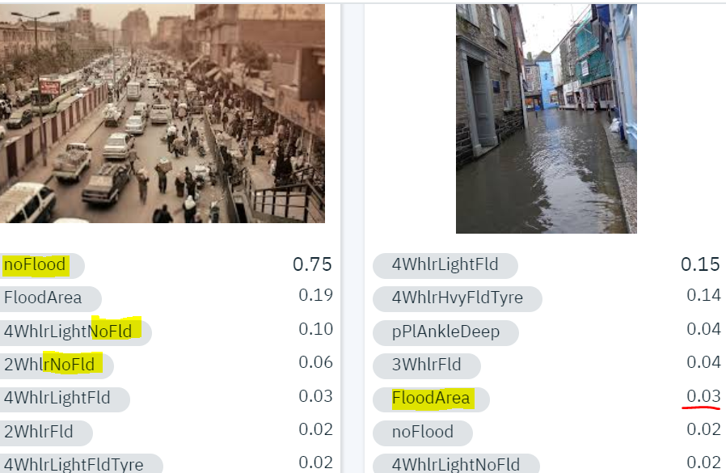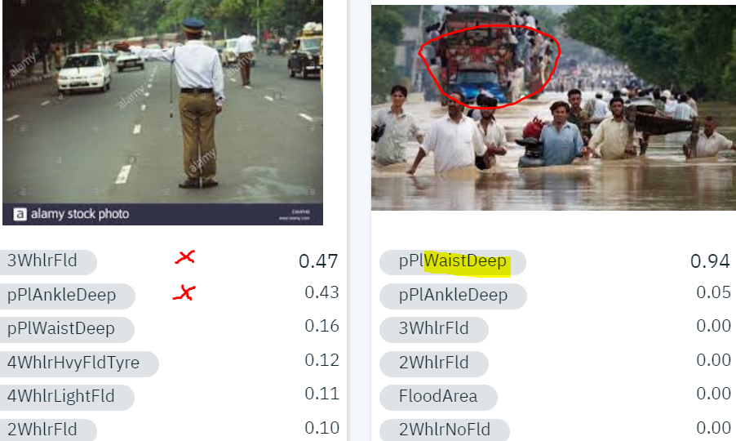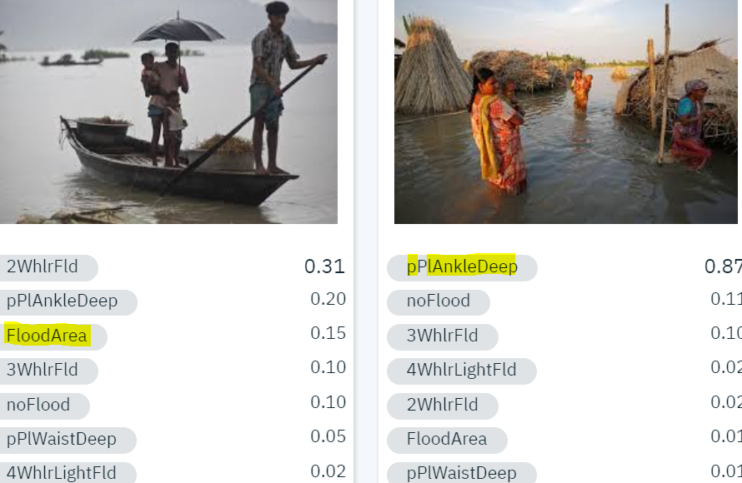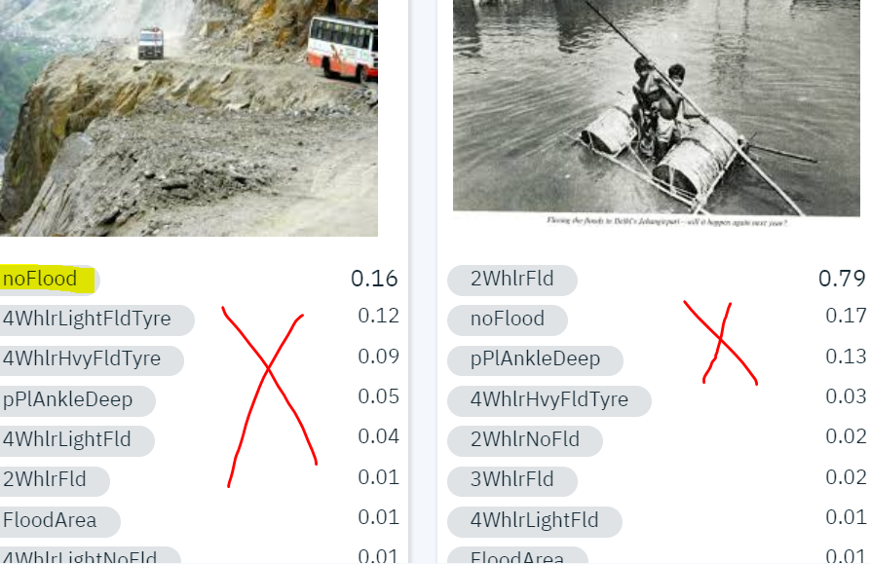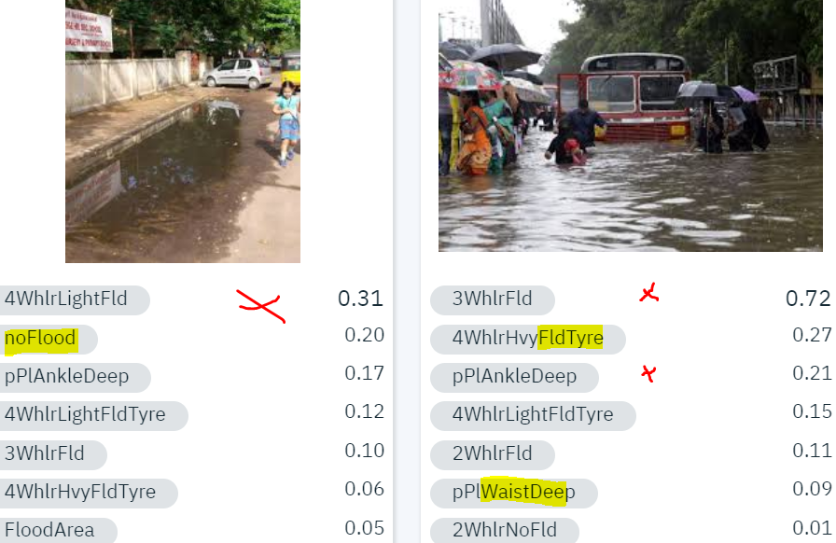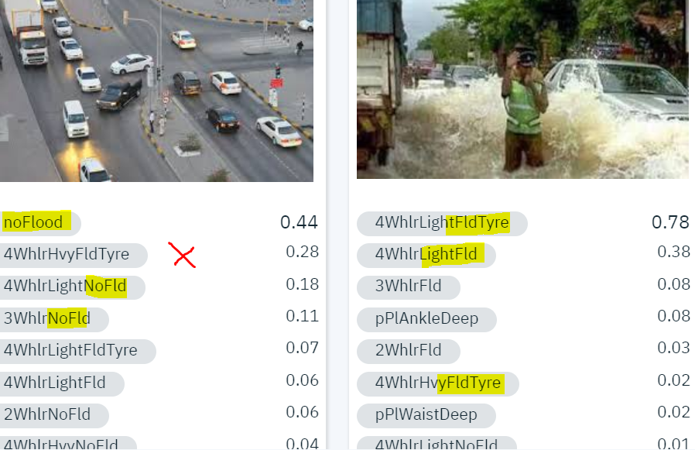

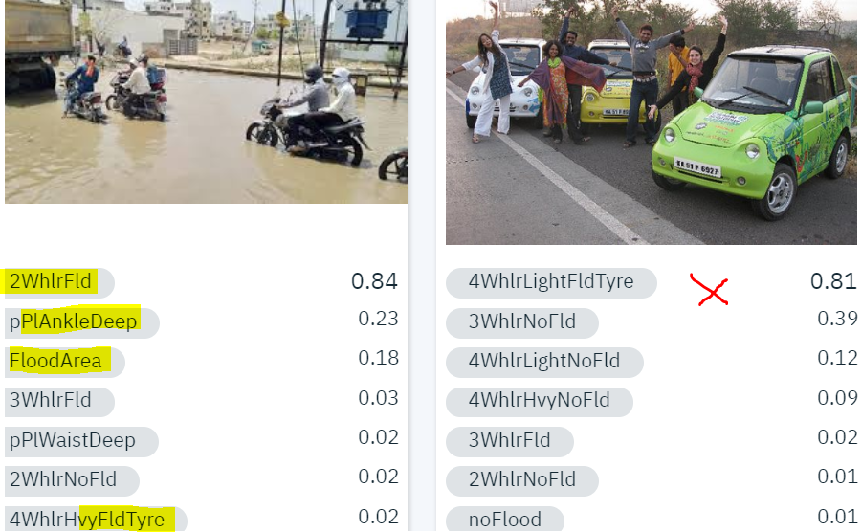

# Round2

